Crop Classification and Clustering System

Project Id: AIML-4

Name :Atharv Rawat (Team Leader)
Class Roll Number: 40
University Roll Number :2028679
Section and Group: K - G1

Name : Kashish Rajput
Class Roll Number:15
University Roll Number : 2028444
Section and Group:K-G1

Name : Dhananjay Sharma
Class Roll Number:11
University Roll Number : 2028412
Section and Group: K-G1

- Problem Description:
Agricultural productivity varies significantly across regions due to complex interactions between environmental, soil, and resource-related factors. Traditional classification methods fail to capture hidden patterns within multi-dimensional agricultural data.
This project aims to design and develop a K-Means clustering–based analytical system to group agricultural regions based on 20 critical features such as rainfall, temperature, soil nutrients (NPK), irrigation coverage, groundwater level, and crop yield characteristics. The system will identify naturally occurring clusters of regions with similar agricultural profiles.
Such clustering enables better decision-making for crop planning, irrigation management, and policy formulation. It can help governments and agri-tech organizations optimize resource allocation, predict region-specific risks, and promote sustainable farming practices. Additionally, the system will be capable of assigning new regions to existing clusters, making it scalable and applicable in real-world agricultural analytics.

- Steps of Implementation:
1. Data Collection
A structured dataset will be created or collected containing 20 region-level agricultural features such as rainfall, temperature, soil properties (pH, NPK), irrigation coverage, groundwater level, crop yield, and mechanization score. The dataset will represent multiple agricultural regions (district/state level) to ensure diversity and variability in patterns.

2. Exploratory Data Analysis (EDA)
EDA will be performed to understand the dataset and identify underlying patterns:
- Analyze feature distributions using histograms and density plots
- Use boxplots to detect outliers in variables like yield and rainfall
- Generate a correlation heatmap to identify relationships between features (e.g., rainfall vs soil moisture)
- Study variability across regions to understand clustering potential
This step ensures a strong understanding of the data before applying algorithms.

3. Data Cleaning
- Handle missing values using mean, median, or interpolation techniques
- Remove duplicate records if present
- Detect and treat outliers using IQR or Z-score methods
- Ensure consistency in units (e.g., mm, %, kg/hectare)
Clean data is critical for meaningful clustering results.

4. Data Preprocessing and Normalization
Since K-Means is distance-based, all features must be on the same scale:
- Apply Standardization (Z-score normalization) to bring all features to comparable ranges
- Transform skewed features if necessary (log transformation)
This prevents features with large magnitudes (like rainfall or area) from dominating clustering.

5. Feature Engineering
New meaningful features may be derived to enhance clustering quality:
- Water Stress Index (rainfall vs groundwater level)
- Input Intensity (fertilizer + pesticide usage)
- Soil Fertility Score (combination of NPK values)
These derived features help capture real agricultural conditions more effectively.

6. Feature Selection (Correlation-based Feature Selection (CFS))
To reduce dimensionality and improve clustering:
- Remove highly correlated features to avoid redundancy
- Use forward/backward elimination techniques to retain only significant features
- Evaluate impact of features on clustering performance
This step improves both efficiency and interpretability of clusters.

7. Dimensionality Reduction (PCA)
- Apply Principal Component Analysis (PCA) to reduce high-dimensional data into 2D/3D space
- Retain maximum variance while reducing complexity
- Helps in visualizing clusters effectively

8. Determination of Optimal Number of Clusters (Elbow Method)
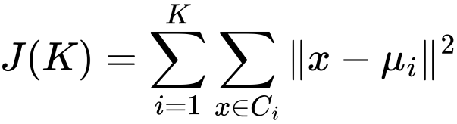
- Compute WCSS (Within-Cluster Sum of Squares) for different values of K
- Plot K vs WCSS graph
- Identify the “elbow point” where reduction slows down
- Select optimal K based on this point

9. Model Building – K-Means Clustering
- Initialize K centroids randomly
- Assign each data point to the nearest centroid
- Update centroids iteratively
- Repeat until convergence (centroids stabilize)
This groups agricultural regions into clusters based on similarity.

10. Cluster Evaluation (Silhouette Score)
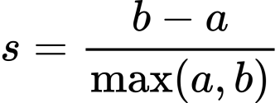​
- Measure how well each data point fits within its cluster
- Compare intra-cluster distance (a) and nearest-cluster distance (b)
- A higher score indicates well-separated and meaningful clusters

11. Post-Clustering Analysis
- Analyze each cluster’s characteristics (e.g., high rainfall–high yield regions)
- Compute mean values of features per cluster
- Label clusters (e.g., “High Productivity”, “Water-Scarce”, etc.)
This step converts raw clusters into actionable insights.

12. Visualization of Clusters
- Use PCA-based scatter plots to visualize clusters in 2D/3D
- Plot cluster boundaries and centroids
- Use color coding for clear differentiation
Visualization helps in interpretation and presentation.

13. Prediction for New Data Points
- Input: new region’s feature values
- Preprocess and scale input data
- Assign cluster label using trained K-Means model
This demonstrates real-world usability of the system.

14. System Integration (Optional Enhancement)
- Build a simple interface using Streamlit
- Allow users to input region data and get cluster classification
- Display insights and recommendations

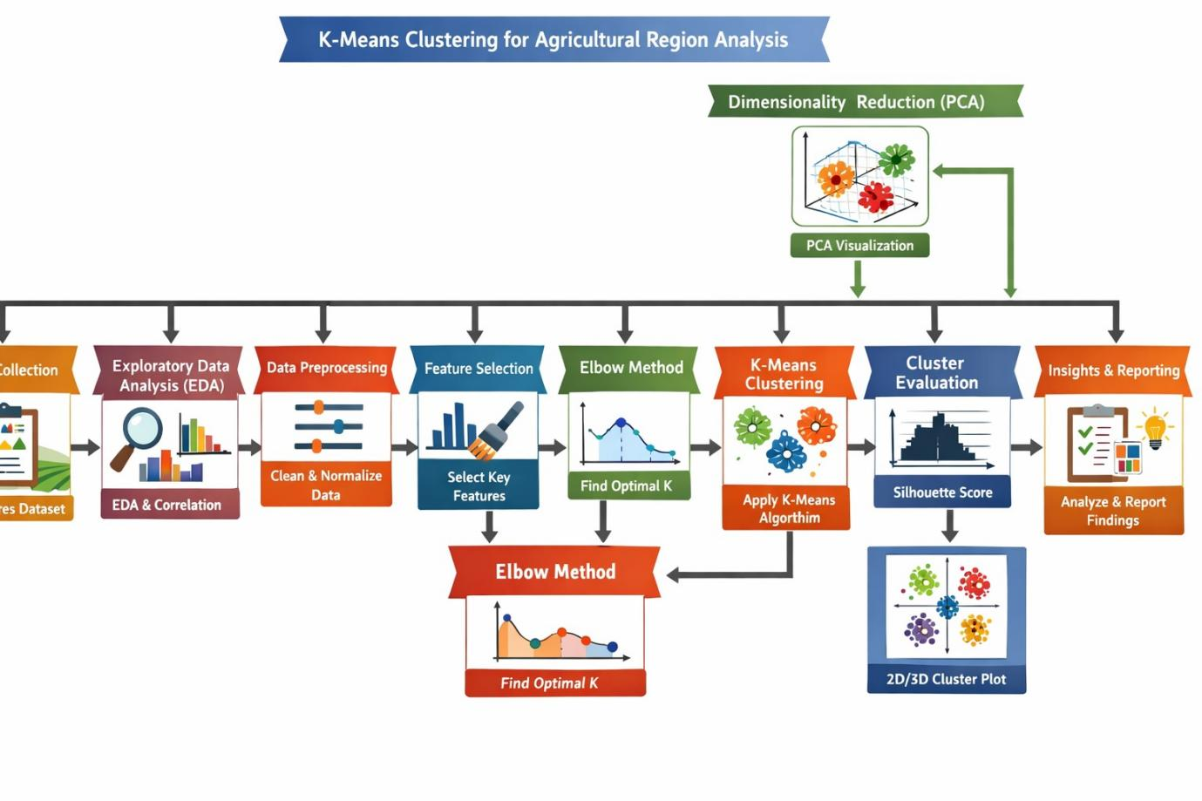
Architecture diagram

Expected Modules/ Libraries to be used :
- NumPy – Used for fast numerical computations and handling multi-dimensional arrays.
- Pandas – Used for data manipulation, cleaning, and handling structured datasets.
- Matplotlib – Used for basic data visualization like plots and graphs.
- Seaborn – Used for advanced statistical visualizations like heatmaps and distributions.
- Scikit-learn – Used for K-Means clustering, PCA, scaling, and evaluation metrics

Expected Evaluation metrics and Plots to be used:
Metrics:
- Silhouette Score – Measures how well each data point fits within its cluster compared to other clusters; values closer to 1 indicate well-separated clusters.
- WCSS (Within-Cluster Sum of Squares / Inertia) – Measures the compactness of clusters by calculating the distance of points from their respective centroids; lower values indicate tighter clusters.

Plots:
- Elbow Curve (K vs WCSS) – Used to determine the optimal number of clusters by identifying the point where reduction in WCSS slows down significantly.
- Silhouette Plot – Visualizes how well each point lies within its cluster, helping assess cluster quality and separation.
- PCA Scatter Plot – Displays clusters in reduced 2D/3D space for easy visualization and interpretation of grouping patterns.
- Correlation Heatmap – Shows relationships between features, helping identify redundant or highly correlated variables before clustering.

- Required topics from the subject:
- File Handling
Used to read and write datasets (CSV files), store processed data, and save clustering results or outputs.
- Data Structures (Arrays / DataFrames)
Used to organize and manage large agricultural datasets efficiently, where rows represent regions and columns represent features.
- Functions / Modular Programming
Used to divide the ML pipeline into reusable components like preprocessing, clustering, and evaluation for better structure and readability.
- Basic Statistics
Required for understanding data distribution, mean, variance, normalization, and evaluation metrics like WCSS and Silhouette Score.
- Visualization Concepts
Used to interpret data through graphs like heatmaps, scatter plots, and elbow curves for better decision-making.

- Platform Required:
- Jupyter Notebook (EDA, modeling, visualization)
- Visual Studio Code (project development)

Books and Link Sources:
Books:
- Introduction to Machine Learning with Python – Andreas Müller
- Pattern Recognition and Machine Learning – Bishop
- Hands-On Machine Learning with Scikit-Learn and TensorFlow: Concepts, Tools, and Techniques to Build Intelligent Systems - Aurelien Geron

Links:
- https://scikit-learn.org/stable/modules/clustering.html
- https://scikit-learn.org/stable/modules/generated/sklearn.metrics.silhouette_score.html

- http://data.icrisat.org/dld/src/gdp.html
- http://data.icrisat.org/dld/src/environment.html
- http://data.icrisat.org/dld/src/infrastructure.html
- http://data.icrisat.org/dld/src/inputs.html
- http://data.icrisat.org/dld/src/biophysical.html
- http://data.icrisat.org/dld/src/irrigation.html
- http://data.icrisat.org/dld/src/crops.html

